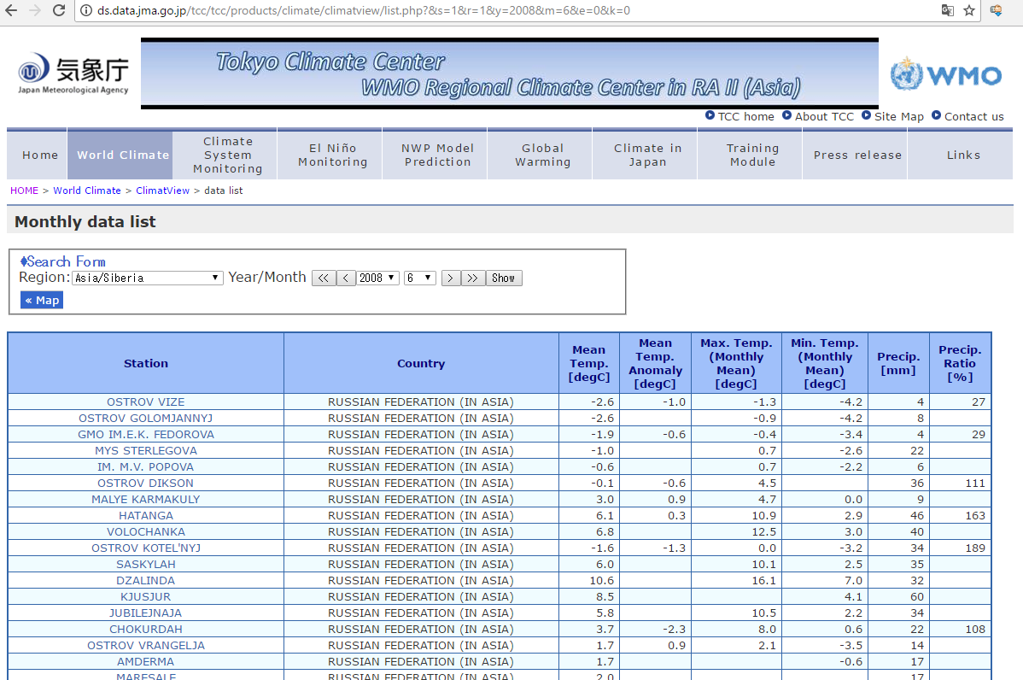
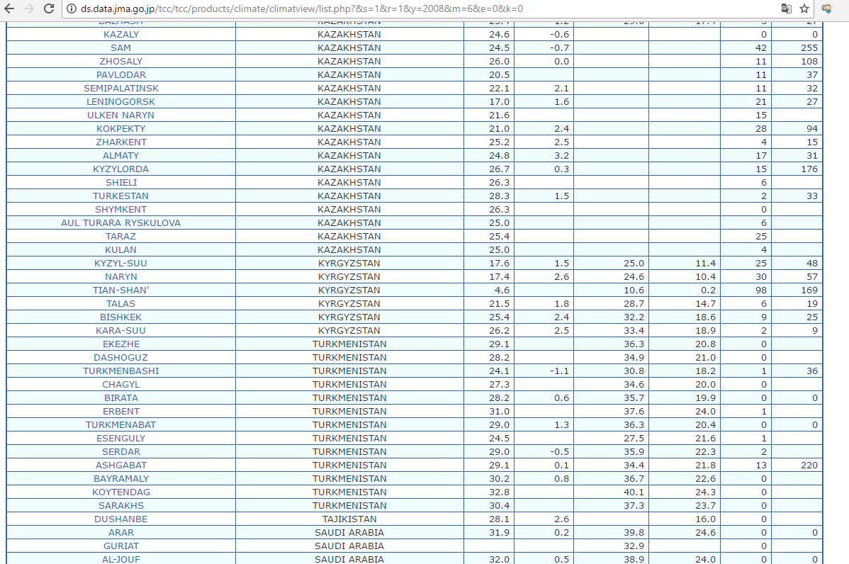
http://ds.data.jma.go.jp/tcc/tcc/products/climate/climatview/list.php?&s=1&r=1&y=2008&m=6&e=0&k=0

